Exercise #3
on course “Cryptography…..”
topic: Rivest Code 2



Task

Realizati Algoritmul RIVEST CODE 2 Conform Schemei de mai jos.
Mesajul de criptare m = “approval”
Subkey = CV
(este keia ce consta din initialele Nume Prenume: Fomenco Vasile FV, Mesajul din 8 simboluri obligatoriu la alegere. Fiecare student utilizeaza strict cheile corespunzatoare)

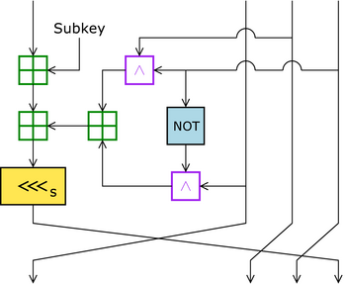

“approval” in binary
01100001 01110000 01110000 01110010
01101111 01110110 01100001 01101100
a => (01100001 01110000) b => (01110000 01110010)
c => (01101111 01110110) d => (01100001 01101100)
Subkey =CV=>(01000011 01010110)

- a + subkey=>(01100001 01110000+01000011 01010110) mod 2^32=
(24944 +17238) mod 2^32 = 42182 = 10100100 11000110

- c^d=> 01101111 01110110 &
01100001 01101100=
01100001 01100100

- (not d) ^ b= 1001111010010011 &
0111000001110010=
1000000010010
- (pt2) + (pt3) => (01100001 01100100+ 00010000 00010010 )mod2^32 =>
(24932+4114)mod2^32=29046=>( 0111000101110110)

- (pt1)+(pt4) = (10100100 11000110 + 01110001 01110110) mod2^32 =>
(42182+ 29046) mod 2^32 = 71228 mod 2^32 =>71228 => (100010110 00111100)

- Deplasament la stanga cu 4 (<<<4): 00000000 00010001 01100011 11000000

- b => (01110000 01110010) c => (01101111 01110110)
d => (01100001 01101100) a=>(00000000 00010001 01100011 11000000)

- Concatenare b,c,d,a => (01110000 01110010 01101111 01110110 01100001 01101100 00000000 00010001 01100011 11000000)

Result = "proval" + "1163c0"

DECRIPTARE

- Deplasamentul a la dreapta cu 4 (>>>4):
00000000 00010001 01100011 11000000 (>>>4):
00000000000000010001011000111100

- c^d=> 01101111 01110110 &
01100001 01101100=
01100001 01100100

- (not d) ^ b= 1001111010010011 &
0111000001110010=
1000000010010

- (c ^d) + (not d ^b) => 1100001 01100100 + 1000000010010) mod2^32 =>
(24932+ 4114) mod 2^32 = 29046 => (111000101110110)

- (a - (b ^ (not d) + (c ^ d) )) =>
( 00000000000000010001011000111100 –
111000101110110) mod2^32=>
(71228 - 29046)mod2^32=>
42182=> (00000000000000001010010011000110)

- (pt5) - CV=>(00000000000000001010010011000110 - 01000011 01010110) mod 2^32 =>(42182 -17238) mod2^32=24944=>0110000101110000

Concatenare a ,b,c,d => 0110000101110000 01110000 01110010 01101111 01110110 01100001 01101100

Result = “approval”
Code listing:

import java.math.BigInteger;
import java.nio.charset.StandardCharsets;
import java.util.ArrayList;
import java.util.List;
public class RC2 {
public static void main(String[] args) {
String text = "approval";
String key = "CV";
System.out.println("Given text: " + text);
System.out.println("Given key: " + key);
String binaryText = new BigInteger(text.getBytes(StandardCharsets.UTF_8)).toString(2);
binaryText = String.format("%64s", binaryText).replaceAll(" ", "0");
String binaryKey = new BigInteger(key.getBytes(StandardCharsets.UTF_8)).toString(2);
binaryKey = String.format("%16s", binaryKey).replaceAll(" ", "0");
System.out.println("Given word in binary: " + prettyBinary(binaryText, 8, " "));
System.out.println("Given key in binary: " + prettyBinary(binaryKey, 8, " "));
StringBuilder a1 = new StringBuilder();
for (int i = 0; i < 16; ++i) {
a1.append(binaryText.charAt(i));
}
String a = a1.toString();
StringBuilder b1 = new StringBuilder();
for (int i = 16; i < 32; ++i) {
b1.append(binaryText.charAt(i));
}
String b = b1.toString();
StringBuilder c1 = new StringBuilder();
for (int i = 32; i < 48; ++i) {
c1.append(binaryText.charAt(i));
}
String c = c1.toString();
StringBuilder d1 = new StringBuilder();
for (int i = 48; i < 64; ++i) {
d1.append(binaryText.charAt(i));
}
String d = d1.toString();
System.out.println("a = " + prettyBinary(a, 8, " "));
System.out.println("b = " + prettyBinary(b, 8, " "));
System.out.println("c = " + prettyBinary(c, 8, " "));
System.out.println("d = " + prettyBinary(d, 8, " "));
// Step 1
int part1Int = (Integer.parseInt(a, 2) + Integer.parseInt(binaryKey, 2));
String part1 = Integer.toBinaryString(part1Int);
part1 = String.format("%32s", part1).replaceAll(" ", "0");
System.out.println("\nStep 1: a + key = " + part1Int + " = " + part1);
// Step 2
int part2Int = Integer.parseInt(c, 2) & Integer.parseInt(d, 2);
String part2 = Integer.toBinaryString(part2Int);
part2 = String.format("%32s", part2).replaceAll(" ", "0");
System.out.println("\nStep 2: c ^ d = " + part2);
//Step 3
int part3Int = ~Integer.parseInt(d, 2) & Integer.parseInt(b, 2);
String part3 = Integer.toBinaryString(part3Int);
part3 = String.format("%32s", part3).replaceAll(" ", "0");
System.out.println("\nStep 3: (not d) ^ b = " + part3);
//Step 4
int part4Int = part2Int + part3Int;
String part4 = Integer.toBinaryString(part4Int);
part4 = String.format("%32s", part4).replaceAll(" ", "0");
System.out.println("\nStep 4: (c ^ d) + ((not d) ^ b) = " + part4);
// Step 5
int part5Int = part1Int + part4Int;
String part5 = Integer.toBinaryString(part5Int);
part5 = String.format("%32s", part5).replaceAll(" ", "0");
System.out.println("\nStep 5: a + key + (c ^ d) + ((not d) ^ b) = " + part5);
// Step 6
int part6Int = part5Int << 4;
String part6 = Integer.toBinaryString(part6Int);
part6 = String.format("%32s", part6).replaceAll(" ", "0");
System.out.println("\nStep 6: part5 <<< 4 = " + part6);
// Step 7
a = part6;
System.out.println("b => " + b + "\n" + "c => " + c + "\n" + "d => " + d + "\n" + "a => " + a);
// Step 8
String bcd = b.concat(c).concat(d);
String encryption = bcd.concat(a);
System.out.println("Concatenating b, c, d, a => " + prettyBinary(encryption, 8, " "));
// Result
String result = "";
int aDecimal = Integer.parseInt(a, 2);
String aHex = Integer.toString(aDecimal, 16);
for (int i = 0; i < bcd.length()/8; i++) {
int az = Integer.parseInt(bcd.substring(8*i,(i+1)*8),2);
result += (char)(az);
}
System.out.println("Result = " + "\"" + result + "\"" + " + \"" + aHex + "\"");
// Decryption
System.out.println("\n===================DECRYPTION===================");
//Step 1
part5Int = part6Int >>> 4;
part5 = Integer.toBinaryString(part5Int);
part5 = String.format("%32s", part5).replaceAll(" ", "0");
System.out.println("Step 1: part6 >>> 4 = " + part5);
// Step 2
System.out.println("\nStep 2: c ^ d = " + part2);
//Step 3
System.out.println("\nStep 3: (not d) ^ b = " + part3);
//Step 4
System.out.println("\nStep 4: (c ^ d) + ((not d) ^ b) = " + part4);
// Step 5
int part5IntDecrypt = part5Int - part4Int;
String part5Decrypt = Integer.toBinaryString(part5IntDecrypt);
part5Decrypt = String.format("%32s", part5Decrypt).replaceAll(" ", "0");
System.out.println("\nStep 5: (a - (b ^ (not d) + (c ^ d) )) => " + part5IntDecrypt + " = " + part5Decrypt);
// Step 6
part6Int = part5IntDecrypt - Integer.parseInt(binaryKey, 2);
part6 = Integer.toBinaryString(part6Int);
part6 = String.format("%16s", part6).replaceAll(" ", "0");
System.out.println("\nStep 6: part5 - CV => " + part6Int + " = " + part6);
// Step 7
result = "";
String abcd = part6.concat(b).concat(c).concat(d);
for (int i = 0; i < abcd.length()/8; i++) {
int az = Integer.parseInt(abcd.substring(8*i,(i+1)*8),2);
result += (char)(az);
}
System.out.println("Result = " + "\"" + result + "\"");
}
public static String prettyBinary(String binary, int blockSize, String separator) {
List<String> result = new ArrayList<>();
int index = 0;
while (index < binary.length()) {
result.add(binary.substring(index, Math.min(index + blockSize, binary.length())));
index += blockSize;
}
return String.join(separator, result);
}
}
Results:

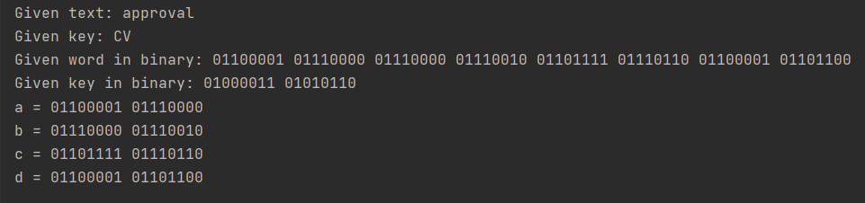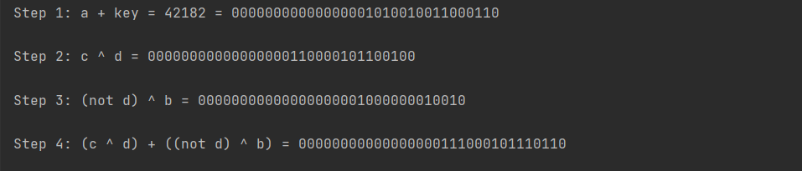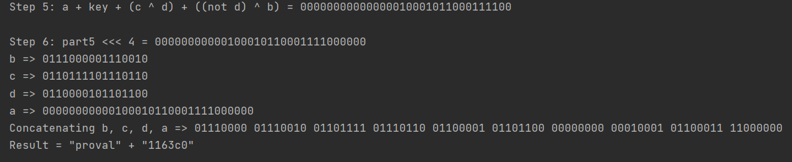

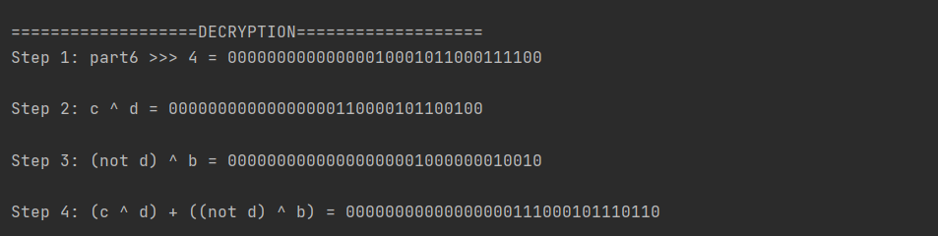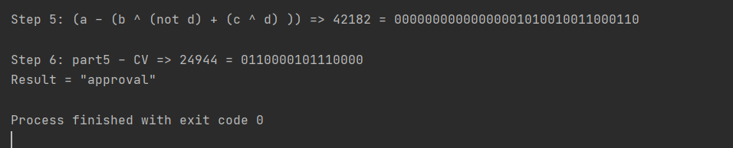
Conclusion:

Применив симметричный алгоритм шифрования RC2, удалось зашифровать слово “approval” вручную. В результате ручной расшифровки результат совпал с начальным словом. Результаты ручного вычисления совпали с результатами запрограммированного алгоритма, что подтверждает правильность ответа.
Bibliography:

Code: The Hidden Language of Computer Hardware and Software, Book by Charlez Petzold, Microsoft Press, October 23, 1999

Serious Cryptography: A Practical Introduction to Modern Encryption, Book by Jean-Philippe Aumasson, 2017

Cryptography, Book by Rubinstein-Salzedo Simon, 2018

Information Security, 2Ed: Principles And Practices, book by Mark Stamp, 2018

Introduction to Cryptography, Book by Sahadeo Padhye, Rajeev A.Sahu, Vishal Saraswat, 2018

